FULLY WORKED SOLUTIONS
Chapter 16: The eyes have it
Chapter questions
1. $\frac{1}{f}=\frac{2(n−1)}{R}$
$R=2f(n−1)$ = 2 × 10 × (1.60 –1) = 12 cm
2. f ∝ R
(a) If R is tripled, f is tripled, so f = 20 × 3 = 60 cm
(b) If R is halved, f is halved, so f = 20/2 = 10 cm
3. (a) u > 2f, so image is real, inverted and reduced
(b) u = f, so image is formed at infinity
(c) u < f, so image is virtual, erect and enlarged
4. (a) u = 40 cm, f = 25 cm
$\begin{aligned}\frac{1}{v}=\frac{1}{f}−\frac{1}{u}=\frac{1}{\text{25}}−\frac{1}{\text{40}}=0\text{.}\text{015} \\ v= \text{66}\text{.}7 \text{cm} (\text{real})\end{aligned}$
(b) $h_{i}= −\frac{{\text{vh}}_{o}}{h_{i}}= −\frac{\text{66}\text{.}7×5}{\text{40}}= −8\text{.}\text{33} \text{cm}$
(c) As v is negative, the image is inverted.
5. u = 10 cm
$\begin{aligned}\frac{h_{i}}{h_{o}}=2 \text{so} −\frac{v}{u}= 2 \\ v=−2×\text{10}= −\text{20} \text{cm} \\ \frac{1}{f}=\frac{1}{u}+\frac{1}{v}=\frac{1}{\text{10}}−\frac{1}{\text{20}}=0\text{.}\text{05} \\ f=\text{20} \text{cm}\end{aligned}$
6. v = –2 cm, f = 4 cm
$\frac{1}{u}=\frac{1}{f}−\frac{1}{v}=\frac{1}{4}−\frac{1}{−2}=0\text{.}\text{75}$
u = 1.33 cm
7. f = –20 cm, u = 30 cm
$\frac{1}{v}=\frac{1}{f}−\frac{1}{u}=\frac{1}{−\text{20}}−\frac{1}{\text{30}}=−0\text{.}\text{083}$
v = –12 cm
8. $\frac{h_{i}}{h_{o}}=\frac{1}{3}$
$\begin{aligned}−\frac{v}{u}=\frac{1}{3} \\ v=−\frac{u}{3}=−\frac{\text{12}}{3}= −4 \text{cm} \\ \frac{1}{f}=\frac{1}{u}+\frac{1}{v}=\frac{1}{\text{12}}−\frac{1}{4}= −0\text{.}\text{166} \\ f= −6 \text{cm}\end{aligned}$
9. f = –30 cm
As image is virtual,
u = –4v
v = –u/4
$\begin{aligned}\frac{1}{f}=\frac{1}{u}+\frac{1}{v} \\ \frac{1}{−\text{30}}=\frac{1}{u}−\frac{4}{u}= − \frac{3}{u} \\ \frac{u}{−3}= −\text{30} \text{cm} \\ u= \text{90} \text{cm}\end{aligned}$

Review questions
5. $\frac{1}{f}=\frac{2(n−1)}{R}$
R =14 cm, n_{glass} = 1.52
$\frac{1}{f}=\frac{2(1\text{.}\text{52}−1)}{\text{14}}$
f = 13.5 cm
6 (a) Red. Red light is reflected back to the retina, and the rest of the spectrum is absorbed
(b) Red. All of the light is reflected back to the retina.
(c) Black. All non-red sections of the spectrum are absorbed so no light is reflected back to the eye.
7. After passing through a blue filter, only blue light will emerge, which won’t pass through the green filter. In reality, small amounts of green light will be passed through the blue filter along with blue light and some violet light. This green light will pass through the green filter.
8. h_{o} = 4 cm, u = 10 cm, f = +6 cm
(a) $\begin{aligned}\frac{1}{f}=\frac{1}{u}+\frac{1}{v} \\ \frac{1}{v}=\frac{1}{6}−\frac{1}{\text{10}} \\ v=\text{15} \text{cm}\end{aligned}$
(b) As v is a positive number, a real image is formed.
(c)
$\begin{aligned}\frac{h_{i}}{h_{o}}=\frac{−v}{u} \\ h_{i}=\frac{−h_{o}v}{u}=\frac{−4×\text{15}}{\text{10}}=−6 \text{cm}\end{aligned}$
9. h_{o} = 5 cm, f = –8 cm, h_{i} = $\frac{5}{2\text{.}5}$ = 2 cm
$\frac{u}{v}=\frac{−h_{o}}{h_{i}}=\frac{−5}{2}= − 2\text{.}5$
u = –2.5v
v = $\frac{−u}{2\text{.}5}$
$\begin{aligned}−\frac{1}{8}=\frac{1}{u}+\frac{1}{v} \\ −\frac{1}{8}=\frac{1}{u}−\frac{2\text{.}5}{u}=−\frac{1\text{.}5}{u} \\ 8=\frac{u}{1\text{.}5}\end{aligned}$
u = 12 cm
The object will need to be placed 12 cm from the lens.
10. (a) f = $\frac{1}{P}=\frac{1}{−4\text{.}0}$ = –0.25 m
(b) Diverging as the focal length is negative
(c) Short-sighted
(d) $\frac{1}{v}=\frac{1}{f}−\frac{1}{u}=\frac{1}{−0\text{.}\text{25}}−\frac{1}{0\text{.}4}=−6\text{.}5$
v = –0.15 m (i.e. 15 cm in front of the lens)
11. (a) Converging lens
(b) Film
(c) Focusing ring
(d) Iris diaphragm and aperture ring assembly
12. f = 5 cm, u = 1500 cm
$\frac{1}{v}=\frac{1}{f}−\frac{1}{u}=\frac{1}{5}−\frac{1}{\text{1500}}=0\text{.}2$
v = 5 cm
13. (a) Substitute values from the diagram for u and v. For example:
u = 30 cm, v = 30 cm
$\frac{1}{f}=\frac{1}{u}+\frac{1}{v}=\frac{1}{\text{30}}+\frac{1}{\text{30}}=\frac{2}{\text{30}}$
f = 15 cm
(b) Virtual, enlarged
(c) Approximately 20 cm beyond the lens
14. u = 20 cm, v = 30 cm
$\frac{1}{f}=\frac{1}{\text{20}}+\frac{1}{\text{30}}=0\text{.}\text{083}$
f = 12 cm (converging)
17. It will act like a diverging lens.
18.
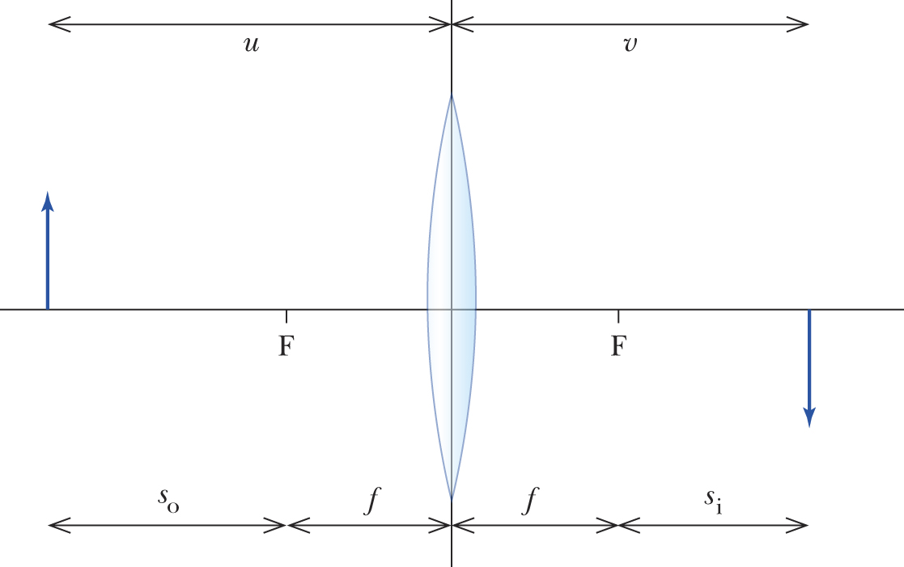
u = s_{o} + f, v = s_{i} + f
$$\begin{aligned}\frac{1}{f}=\frac{1}{u}+\frac{1}{v} \\ \frac{1}{f}=\frac{1}{s_{o}+f}+\frac{1}{s_{i}+f} \\ \frac{1}{f}=\frac{s_{o}+f+s_{i}+f}{(s_{o}+f)(s_{i}+f)} \\ \frac{1}{f}=\frac{s_{o}+s_{i}+2f}{s_{o}s_{i}+s_{i}f+s_{o}f+f^{2}} \\ \frac{s_{o}s_{i}+s_{i}f+s_{o}f+f^{2}}{f}=s_{i}+s_{o}+2f \\ s_{o}s_{i}+s_{i}f+s_{o}f+f^{2}=s_{i}f+s_{o}f+2f^{2} \\ s_{o}s_{i}=f^{2}\end{aligned}$$
19. Starting with the converging lens:
f = 40 cm, u = 80 cm, h_{o} = 5 cm
$$\begin{aligned}\frac{1}{f}=\frac{1}{u}+\frac{1}{v} \\ \frac{1}{\text{40}}=\frac{1}{\text{80}}+\frac{1}{v} \\ \frac{1}{v}=\frac{1}{\text{40}}−\frac{1}{\text{80}}=\frac{1}{\text{80}} \\ v = \text{80} \text{cm} \\ \frac{h_{i}}{h_{o}}=−\frac{v}{u} \\ h_{i}=\frac{−{\text{vh}}_{o}}{u}=−\frac{\text{80}×5}{\text{80}}=−5 \text{cm}\end{aligned}$$
The influence of the diverging lens:
f = -30 cm, u = 100 – 80 = 20 cm, h_{o} = –5 cm (i.e. inverted relative to the object)
$$\begin{aligned}\frac{1}{v}=\frac{1}{f}−\frac{1}{u}=\frac{1}{−\text{30}}−\frac{1}{\text{20}}=−\frac{5}{\text{60}} \\ v= −\text{12} \text{cm}\end{aligned}$$
This means that the final image is virtual, forming at a point 12 cm in front of the diverging lens. This means that it will be 168 cm from the object.
$$\begin{aligned}\frac{h_{i}}{h_{o}}=−\frac{v}{u} \\ h_{i}=−\frac{{\text{vh}}_{o}}{u}=−\frac{(−\text{12})(−5)}{\text{20}}=−3 \text{cm}\end{aligned}$$
The final image will be 3 cm high and inverted relative to the original object.
20. R₂ = ∞, n = 1.55, f = 22.5 cm
$$\begin{aligned}\frac{1}{f}=\left[\left(n−1\right)\left(\frac{1}{R_{1}}−\frac{1}{R_{2}}\right)\right]+\left(\frac{{\left(n−1\right)}^{2}t}{{\text{nR}}_{1}R_{2}}\right) \\ \frac{1}{\text{22}\text{.}5}={\left[(1\text{.}\text{55}−1)\left(\frac{1}{R_{1}}−\frac{1}{∞}\right)\right]}_{+\left(\frac{{\left(1\text{.}\text{55}−1\right)}^{2}t}{1\text{.}\text{55}R_{1}∞}\right)} \\ \frac{1}{\text{22}\text{.}5}=(0\text{.}\text{55})\left(\frac{1}{R_{1}}−0\right)+0 \\ \text{22}\text{.}5=\frac{R_{1}}{0\text{.}\text{55}} \\ R_{1}=\text{12}\text{.}4 \text{cm}\end{aligned}$$

